Assignment – 2

|  |  |
| --- | --- |
| Assignment Date | 29-Sep-2022 |
| Student Name | NanthaKumar |
| Student Roll Number | 952819104034 |
| Maximum Marks | 2 Marks |

Questions:

1. Create user table with email, username, rollnumber and password.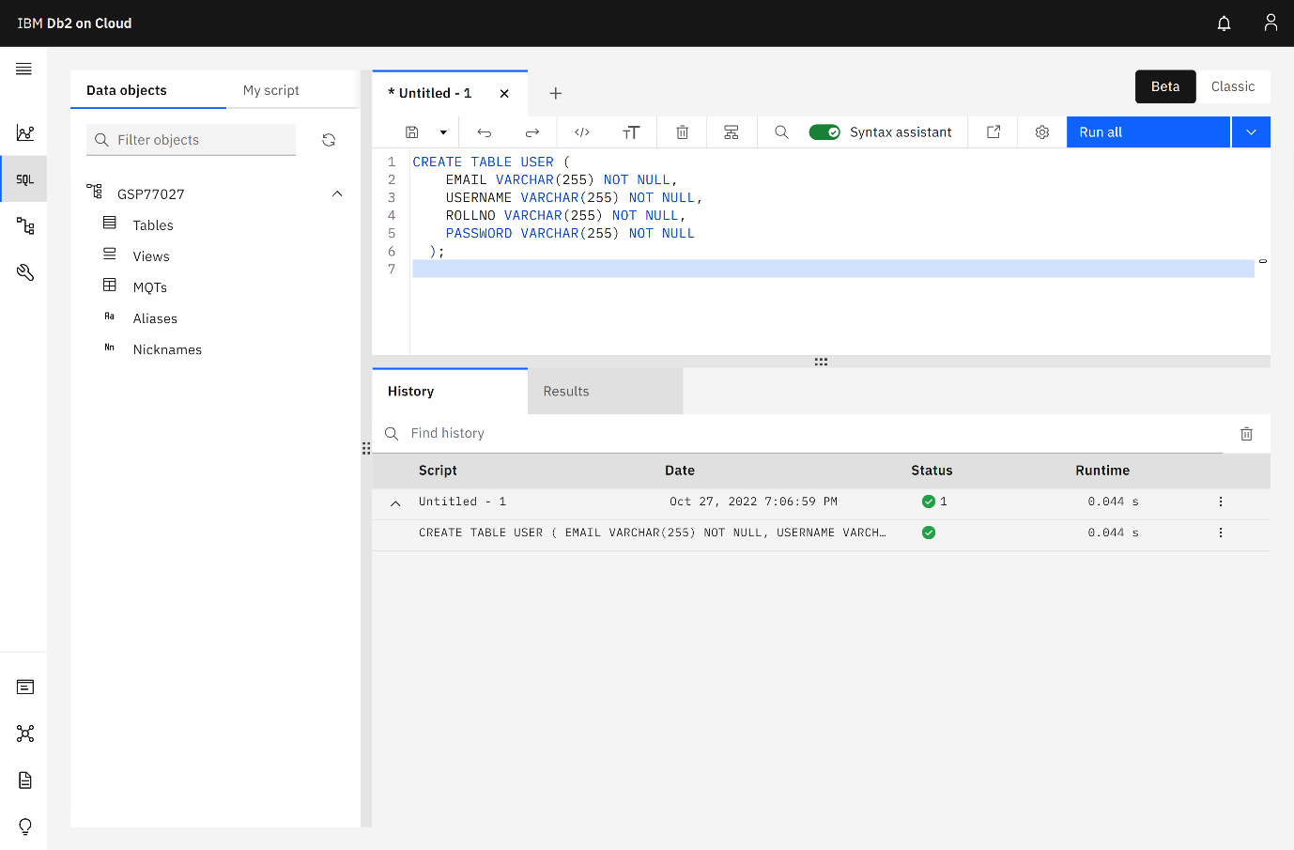
2. Perform UPDATE, DELETE queries with user table.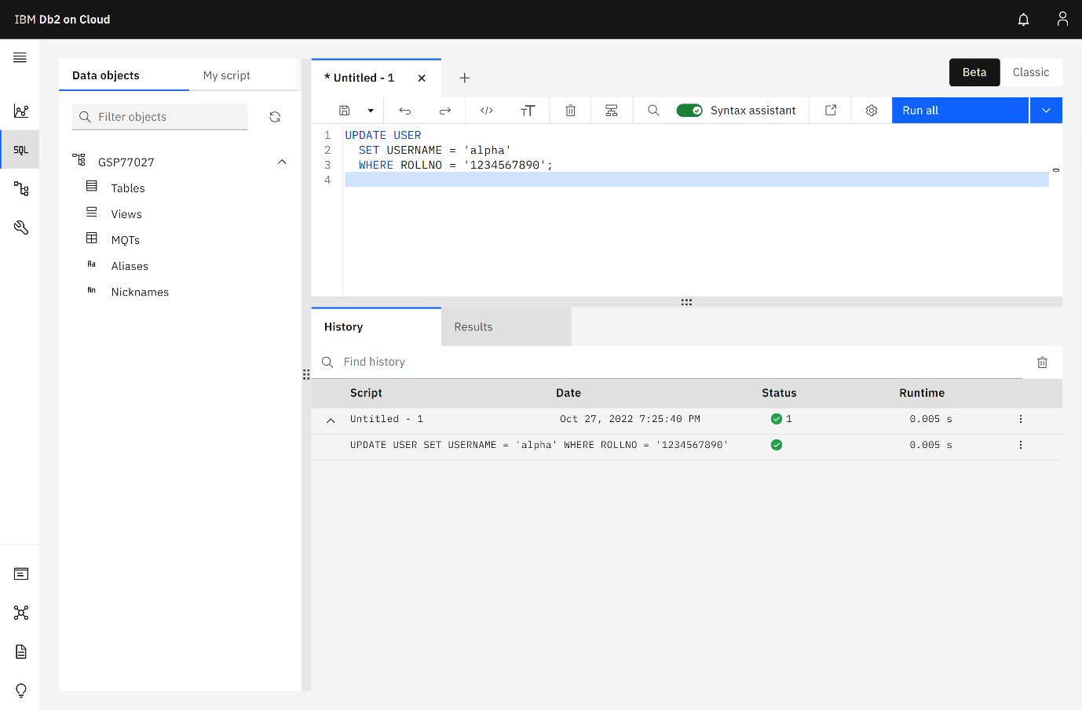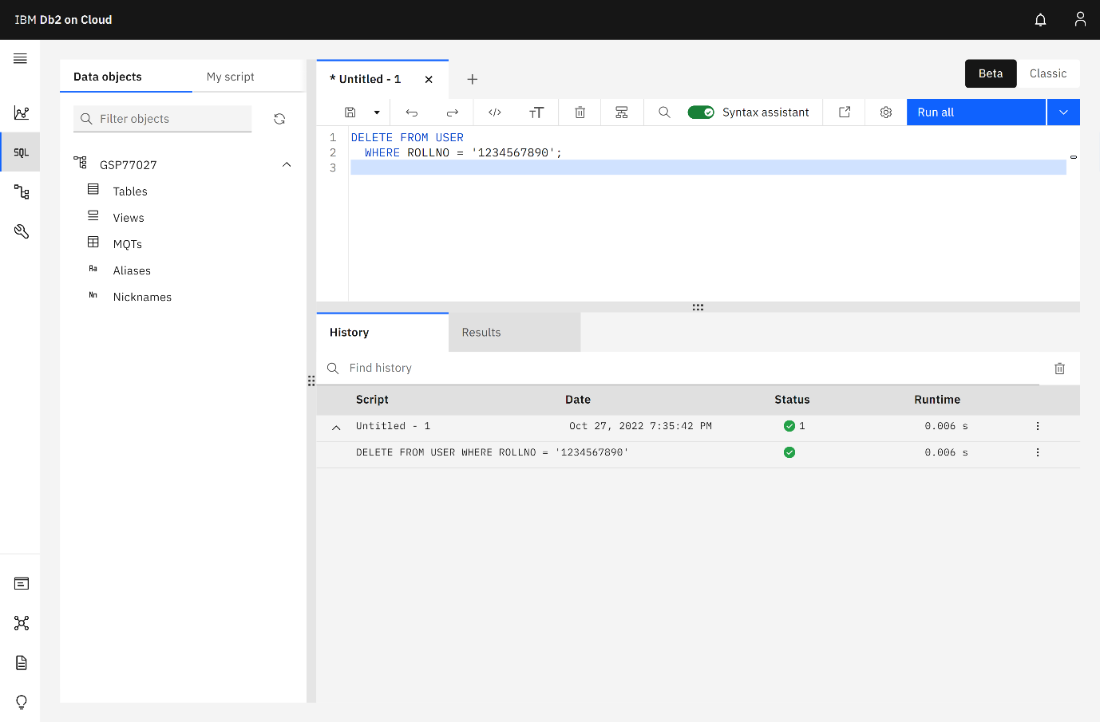
3. See [./code](code)
4. See [./code](code)